6/17/2026
Shekhar Podutwar
17/6/2026
Build and Push Docker Image to Azure Container Registry
Using Azure DevOps Pipeline

Contents

Document Version History……………………………….…………………………………………….1
Introduction…………………….…………………………………………………………………………….2
Objectives…………………….………………………..….………………………………………………….3
Tools & Technologies Used…………………………………………………………………………….4
Architecture Overview ………………………………………………………………………………….5
Step-by-Step Implementation …………………………………..………………………………….6

Document Version History

Version Number | Date Modified | Author | Changes
Draft | 17/6/2026 | Shekhar | Draft Version

Introduction

In modern DevOps practices, containerization and automation play a crucial role in accelerating software delivery. Docker enables applications to be packaged with all their dependencies into portable containers, while Azure Container Registry (ACR) provides a secure and scalable repository for storing container images. Azure DevOps Pipelines automates the process of building, testing, and pushing Docker images to ACR, ensuring faster and more reliable deployments.
This project demonstrates how to create a CI/CD pipeline in Azure DevOps that automatically builds a Docker image from source code and pushes it to Azure Container Registry whenever code changes are committed to the repository.

Objectives

- Automate Docker image build processes using Azure DevOps Pipelines.
- Integrate Azure DevOps with Azure Container Registry (ACR).
- Eliminate manual image creation and deployment tasks.
- Maintain version-controlled Docker images in a centralized registry.
- Enable continuous integration for containerized applications.
- Improve deployment consistency and release efficiency.
Tools and Technologies

Tool/Technology | Purpose
Azure DevOps | Source code management and CI/CD automation
Docker | Containerization platform
Azure Container Registry (ACR) | Private Docker image repository
Azure Subscription | Cloud resource management
Azure Service Connection | Secure authentication between Azure DevOps and Azure
YAML Pipeline | Pipeline as Code implementation
Ubuntu Hosted Agent | Build agent for pipeline execution
Git Repository | Source code version control

Architecture Overview
Developer
│
▼
Azure Repos / GitHub Repository
│
▼
Azure DevOps Pipeline Trigger
│
▼
Build Stage
- Pull Source Code
- Build Docker Image
│
▼
Docker Image
│
▼
Authenticate with Azure
(Service Connection)
│
▼
Azure Container Registry (ACR)
│
▼
Push Docker Image
(app:v1, app:v2, latest)

Workflow
- Developer commits code to the repository.
- Azure DevOps pipeline is automatically triggered.
- Pipeline checks out the application source code.
- Docker builds the image using the Dockerfile.
- Azure DevOps authenticates with Azure through Service Connection.
- The Docker image is tagged with a version number.
- The image is pushed to Azure Container Registry (ACR).
- The image becomes available for deployment to AKS, App Service, or other container platforms.
Step-by-Step Implementation

Build and Push Docker Image to Azure Container Registry (ACR) Using Azure DevOps Pipeline

Step 1: Create an Azure Container Registry (ACR)
- Sign in to the Azure Portal.
- Search for Azure Container Registry and click Create.
- Select:
  - Subscription
  - Resource Group
  - Registry Name (must be globally unique)
  - Region
- Click Review + Create and then Create.
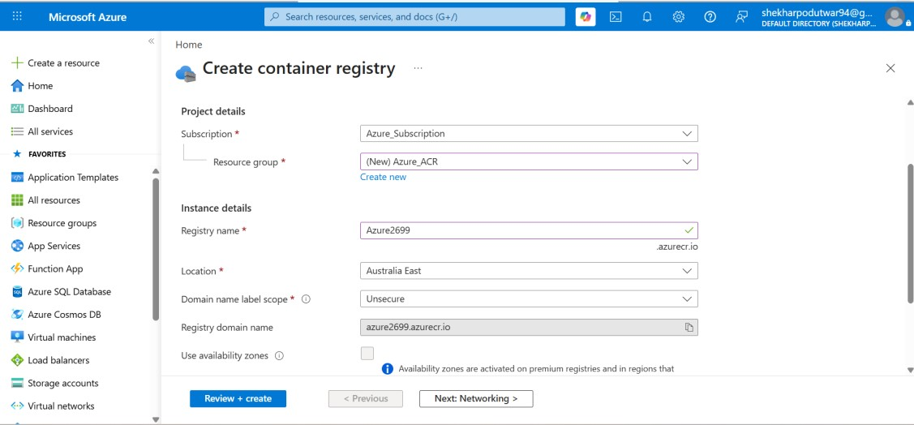
Step 2: Verify the Azure Container Registry
- After deployment is complete, open the newly created Azure Container Registry.
- Navigate to:
  - Services → Repositories
- Initially, the Repositories section will be empty because no images have been pushed yet.
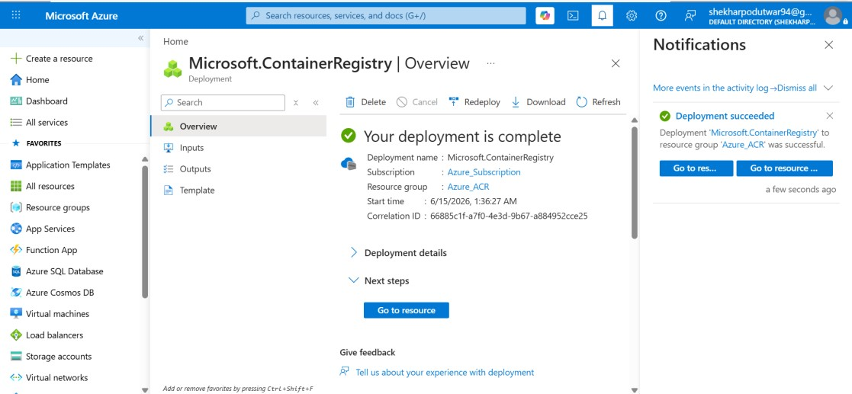
Step 3: Create a Service Connection in Azure DevOps
- Open Azure DevOps.
- Navigate to:
  - Project Settings → Service Connections
- Click New Service Connection.
- Select Docker Registry and click Next.
- Configure the following:
  - Authentication Type: Service Principal
  - Subscription: Select your Azure Subscription
  - Azure Container Registry: Select your ACR (e.g., Azure2699)
- Click Save.
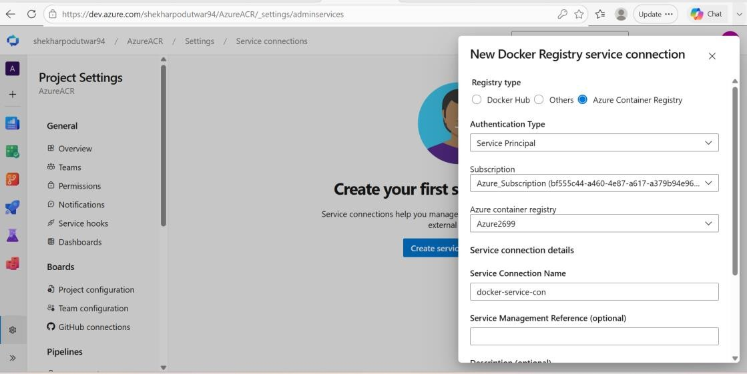
Step 4: Verify the Service Connection
- Go to:
  - Project Settings → Service Connections
- Confirm that the newly created Docker Registry Service Connection is listed and active.
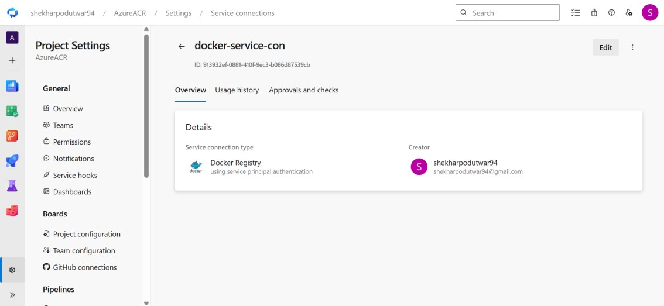
Step 5: Create a Dockerfile
- In your Azure Repos repository, create a Dockerfile.
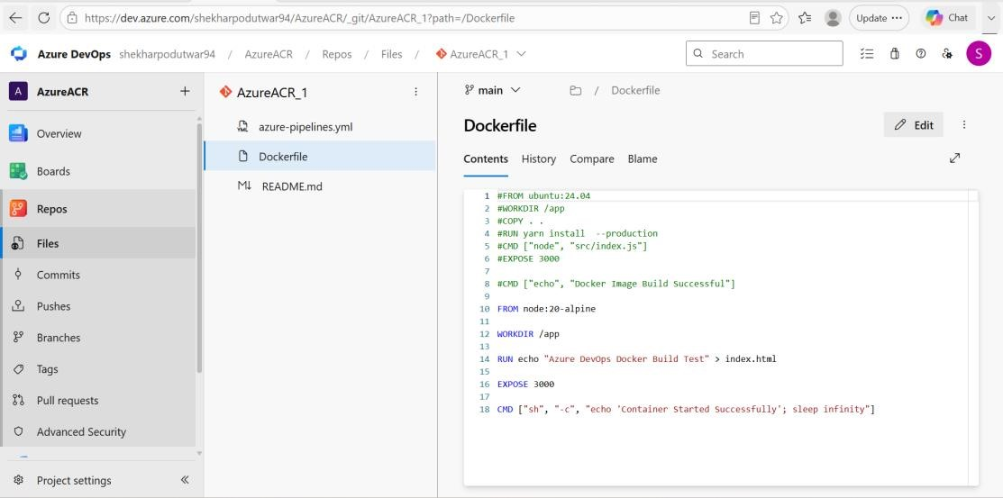
Step 6: Create an Azure DevOps Pipeline
- Navigate to Pipelines.
- Click New Pipeline.
- Select:
  - Azure Repos Git
  - Your Repository
- Choose Starter Pipeline.
- Replace the default YAML with the following configuration:
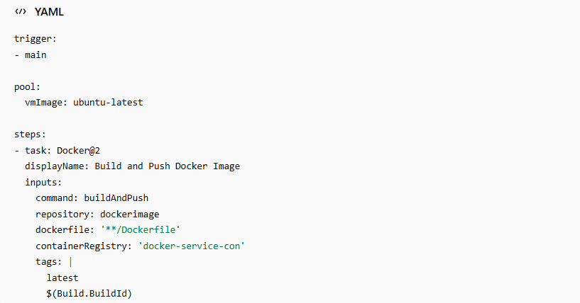

Configure the following:
- Container Registry Service Connection (ex: docker-service-con)
- Repository Name (ex: dockerimage)
- Dockerfile Path
- Build and Push Command
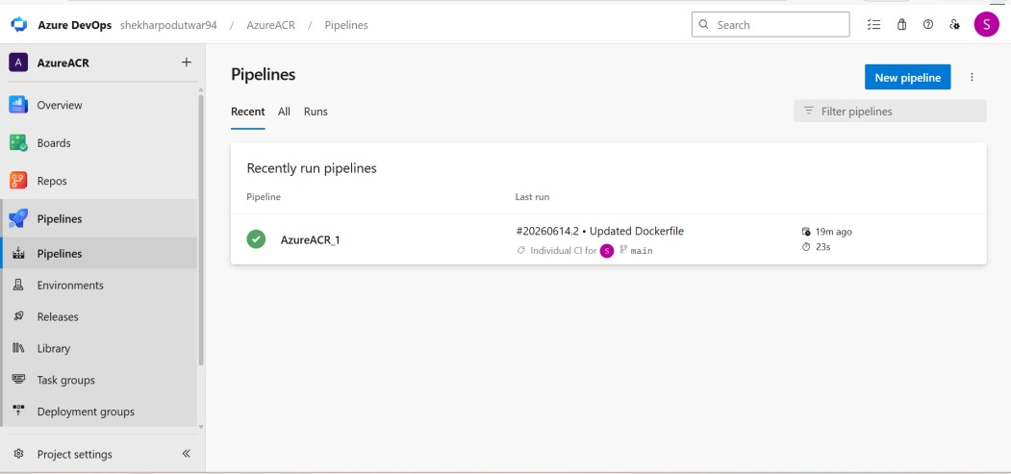
Step 7: Save and Run the Pipeline
- Click Save or Commit.
- Navigate to the Pipelines section.
- Select your pipeline.
- Click Run Pipeline.
- Monitor the build logs until the pipeline completes successfully.
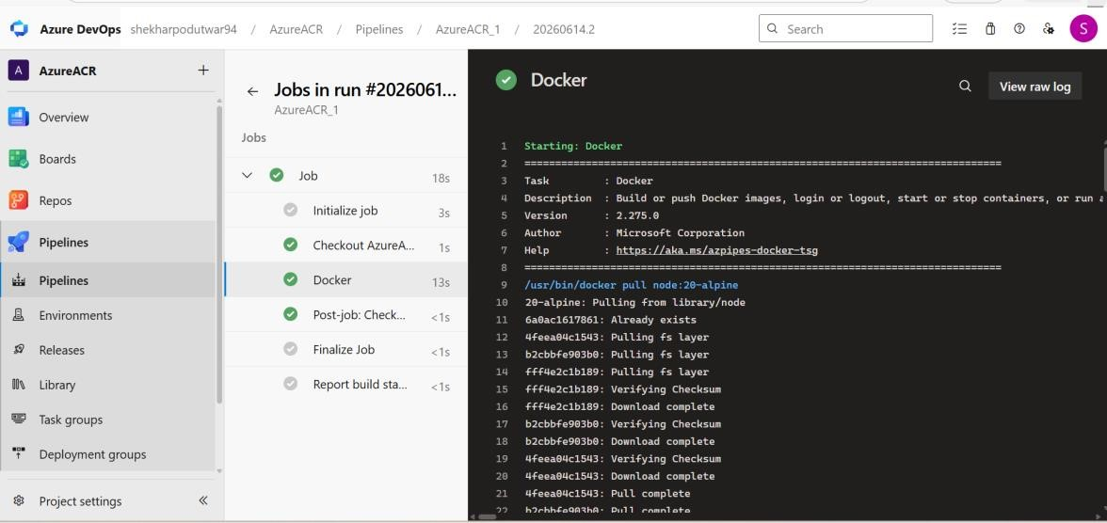

Step 8: Verify the Docker Image in ACR
- Open the Azure Portal.
- Navigate to your Azure Container Registry.
- Go to:
  - Services → Repositories
- You should now see the repository (e.g., dockerimage) along with the image tags.
✅ The Docker image has been successfully built and pushed to Azure Container Registry (ACR).
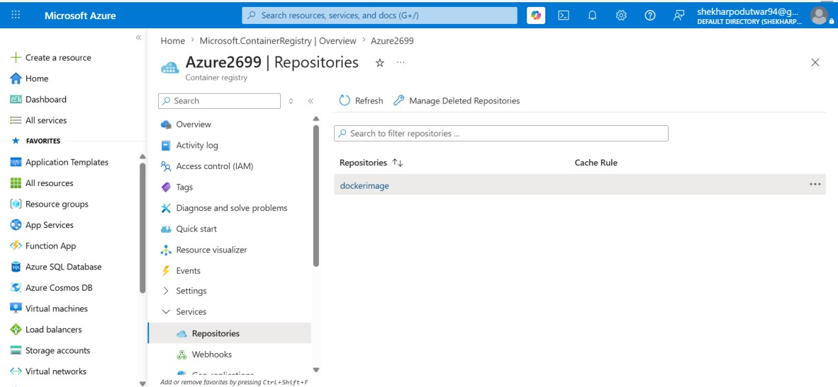

Conclusion

This project successfully implements an automated CI pipeline using Azure DevOps to build and push Docker images to Azure Container Registry. By automating the container image lifecycle, organizations can reduce manual effort, improve consistency, and accelerate application delivery. The solution serves as a foundational step toward implementing complete CI/CD workflows for Azure Kubernetes Service (AKS) and other cloud-native deployment environments.

